Q-0015 Process Corrective and Preventive Action

(Process CAPA)

Revision History
Revision | Status | Change  Order | Date | Description
A | Draft | TBD |  | First draft

Training Requirement
Role | New Personnel | Personnel Trained in  Previous Revision
CAPA Coordinator | Instructor-led | Not applicable for Rev A
CAPA Owners | Instructor-led | Not applicable for Rev A
Management | Instructor-led | Not applicable for Rev A

Purpose
Process Corrective and Preventive Action (Process CAPA) is a method for taking actions to reduce or eliminate the causes of actual or potential problems in the quality system. Stated positively, CAPAs are improvement projects.

Scope
PROCESS CAPA addresses problems that require process changes. It is not intended for product changes, e.g., specification changes, which are addressed in Product Corrective and Preventive Action (Q-0016). Process CAPA includes problem evaluation and analysis, action plans, effectiveness checks to ensure subsequent occurrence of problems has been satisfactorily reduced or eliminated, and documentation and tracking of CAPA activities.

Definitions

Correction
A correction fixes an immediate problem.

Corrective Action
A corrective action prevents recurrence of a problem by reducing or eliminating the causes.

Preventive Action
A preventive action prevents occurrence of a potential problem by reducing or eliminating the causes.

Responsibilities

CAPA Coordinator
The Quality Manager acts as the CAPA Coordinator or appoints an individual(s) to be the CAPA Coordinator. The CAPA Coordinator facilitates CAPA activity, tracks progress, maintains record files, and reports to management on the status of the CAPA activity.

CAPA Owners
The CAPA Coordinator with the agreement of management appoints an owner for each CAPA. The owner is responsible for ensuring the timely completion of associated activities. The owner may be different for each CAPA phase: evaluation, action, and effectiveness check. The owner should be a manager or expert best qualified to ensure the success of the improvement project.

Management
Managers:
- review CAPA evaluation results, root cause analysis, action plan, and effectiveness check plan
- ensure appropriate resources are available to perform the approved actions
- review and approve closure of CAPA projects

Referenced Documents
  - Q-0014 Internal Audits
  - Q-0016 Product CAPA
  - Q-0001 Quality Manual

Records Created
Record Type | Template | Stored | Filed By
Process CAPA Record | Q-0015 Form A | Process CAPA File | Process CAPA number

Process Flow
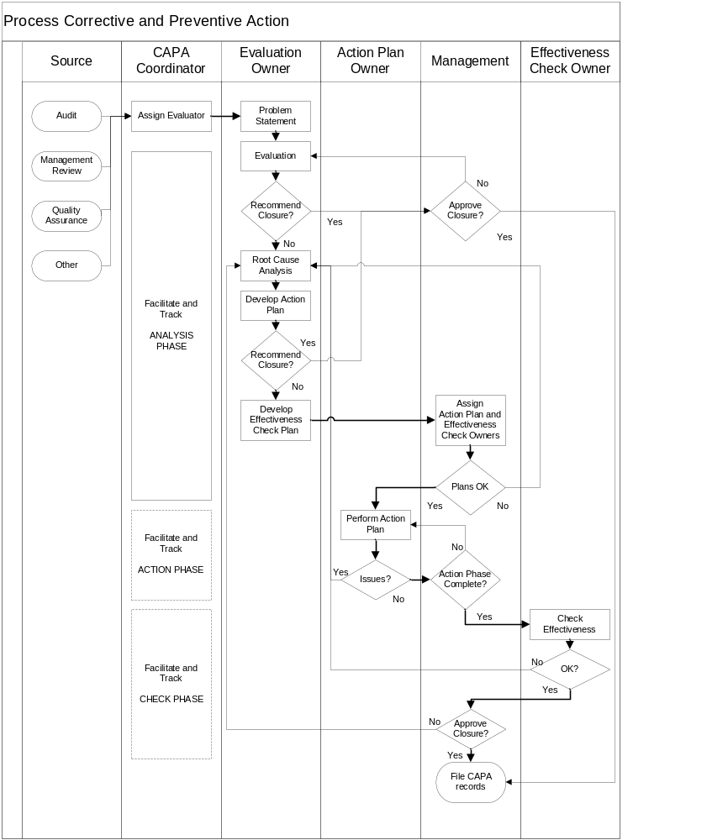

Procedure
Step | Details
Source | An employee decides that a CAPA may be appropriate. (Any observation from a quality system audit or assessment requires a CAPA evaluation.) The individual obtains a CAPA template and enters the Source and Source Text information.
Assign Evaluator | The CAPA Coordinator confirms that the Source and Source Text are sufficient. If not, the CAPA Coordinator facilitates editing by the submitter. The CAPA Coordinator, with the consent of the Quality Manager and the Evaluation Owner’s manager, assigns the CAPA to an Evaluation Owner. The Evaluation Owner should have a working understanding of the issues involved.
Problem Statement | The Evaluation Owner creates a Problem Statement that describes the general problem, not just the observed event. The statement should be a description of the type of problem for which the event is an example.
Evaluation | The Evaluation Owner completes the Evaluation. He or she assesses:  - Is this problem a duplicate of a problem addressed by another open CAPA?  - Do quality system documents describe the appropriate handling of the problem?  - Is the problem systemic, i.e.., do existing practices contribute to the problem?  - Does the problem occur more often than is acceptable?  - Is the safety risk, business risk, or regulatory risk not acceptable?  See the next section for guidance on evaluation.
Recommend closure? | The Evaluation Owner should recommend closure if the problem is a duplicate being addressed by another open CAPA. (If it duplicates a problem in a closed CAPA, that CAPA may not have been effective. Continue to evaluate the new CAPA.)  The Evaluation Owner should recommend closure if the problem is not systemic, occurs rarely, and has acceptable risks.  If closure is recommended, go to Approve Closure? below.
Root Cause Analysis (RCA) | The Evaluation Owner lists the root causes. Correctly identifying root causes is essential to an effective CAPA. There are several RCA techniques. Consultation with the CAPA Coordinator is highly recommended.
Develop Action Plan | The Evaluation Owner, facilitated by the CAPA Coordinator, recommends one or more feasible actions to address each root cause. If there are no feasible actions, the Evaluation Owner shall state, “NO ACTION,” and state a reason.
Recommend closure? | The Evaluation Owner should recommend closure if there is no feasible action to address the causes.  If closure is not recommended, go to Develop Effectiveness Check Plan below.
Approve closure? | If the Quality Manager agrees with the recommendation, he or she signs and dates the “Approval of Quality Manager” block. Go to step File CAPA Records, the last step of the process.  If not, the CAPA form is returned to the Evaluation Owner with comments. The Evaluation Owner continues as appropriate based on the comments.
Develop Effectiveness Check Plan | The Evaluation Owner and the CAPA Coordinator develop a plan to determine that the problem has been satisfactorily addressed. The emphasis should be on identifying occurrence or recurrence of the problem, not on completion of action items.
Assign Action Plan and Effectiveness Check Owners | The Quality Manager and other managers affected by the plans agree on owners for the Action Plan and the Effectiveness Check. The owners should review and comment on the plans. The Quality System Manager and Action Plan owner agree on a target date for completion of the Action Plan.
Plans OK? | The Quality System Manager, Action Plan Owner, Effectiveness Plan Owner, and other involved Managers review the plans. If there is not agreement, the Evaluation Owner should do further evaluation or revise the plans as appropriate.
Perform Action Plan | The Action Plan Owner implements the action plan.
Issues? | If there are issues that prevent timely completion of the Action Plan, consult with the CAPA Coordinator. Changes to the Action Plan require a review of root causes and management approval. If yes, return to the Root Cause Analysis step and determine if the RCA needs to be changed.
Action Phase Complete? | When the Action Plan is completely implemented, the Action Plan Owner and Quality System Manager sign the Action Phase Complete block on the CAPA Form. The Effectiveness Check Owner sets the target date for completion of the Effectiveness Check.
Check Effectiveness | The Effectiveness Check Owner performs the effectiveness check. If results are satisfactory, the Effectiveness Check Owner recommends CAPA closure. If not, the Effectiveness Check Owner informs the CAPA Coordinator and Quality System Manager. They decide whether to pursue another round of corrective action, to check effectiveness again at a later date, or to accept the results as acceptable (although not meeting original criteria). If the results are considered acceptable, the Quality Manager signs the Effectiveness Check Phase Complete box on the CAPA form.
File CAPA records | The CAPA Coordinator reviews the CAPA form appended and referenced data. When the documentation is complete, the CAPA form is filed in the CAPA Archive.

Guidance on CAPA Evaluation
Is the problem a duplicate? | Often an observation yields a problem statement that substantially duplicates a problem statement of an open CAPA. If so, the “duplicate” CAPA may be closed with a reference to the open CAPA and notification to the originator.  Sometimes several problems have the same root causes or the same action plan. If after evaluation, the root causes or the action plan duplicates an open CAPA, the “duplicate” CAPA may be closed with a reference to the open CAPA and notification to the originator.
Relevant quality system documents | Inadequate, non-compliant, or missing policies, processes, or procedures are common causes of problems. The first step in evaluating a problem is determining the relevant quality system documents, or lack thereof.
Is the problem systemic? | Does the quality system contribute to the problem? Are the relevant quality system documents inadequate or noncompliant? Do prevalent practices contribute to the problem?
Frequency | Audits and other observations may note one or a few incidents of noncompliance. Audits, for example, are only a sampling of activities. One needs to understand how often the problem is occurring. Proper evaluation may require a study to determine the frequency of occurrences. Cite the method and/or sources of data used to determine frequency. If the analysis shows the problem occurs in only certain situations, describe those situations.  Frequency estimates often must be subjective. Approximate quantitative equivalents are:  FREQUENT - Occurs more than 10% of the time  OCCASIONAL - Occurs between 1% and 10% of the time  RARE - Occurs less than 1% of the time

Risk Estimation
Safety Risk | Severity of potential harm:  Negligible – Little or no potential of injury  Minor – Potential of injury that does not require professional attention  Moderate – Potential of injury that requires professional attention  Major – Potential of serious injury or death  Likelihood (Applies to how often harm of the severity level occurs, not to how often the problem occurs.):  Impossible – No known causative relationship  Rare – Less than 1% of the time  Occasional – 1%-10% of the time  Frequent – More than 10% of the time
Safety Risk |  | Negligible | Minor | Moderate | Major
Safety Risk | Frequent | Acceptable | Unacceptable | Unacceptable | Unacceptable
Safety Risk | Occasional | Acceptable | ALARP | Unacceptable | Unacceptable
Safety Risk | Rare | Acceptable | ALARP | ALARP | Unacceptable
Safety Risk | Impossible | Acceptable | Acceptable | Acceptable | Acceptable

Business Risk | Severity of potential harm:  Negligible - Customer annoyance. No loss. No legal, PR, or liability exposure.  Minor - Minor customer dissatisfaction. Minor financial loss. Limited exposure.  Moderate – Significant customer dissatisfaction. Moderate financial loss. Significant exposure.  Major – Loss of customer. Major financial loss. Significant exposure.  Likelihood (Applies to how often harm of the severity level occurs, not to how often the problem occurs.):  Impossible – No known causative relationship  Rare – Less than 1% of the time  Occasional – 1%-10% of the time  Frequent – More than 10% of the time
Business Risk |  | Negligible | Minor | Moderate | Major
Business Risk | Frequent | Acceptable | Unacceptable | Unacceptable | Unacceptable
Business Risk | Occasional | Acceptable | ALARP | Unacceptable | Unacceptable
Business Risk | Rare | Acceptable | ALARP | ALARP | Unacceptable
Business Risk | Impossible | Acceptable | Acceptable | Acceptable | Acceptable

Regulatory Risk | Severity of potential harm:  Negligible - Single case of an incorrect record. Non-violative situation.  Minor - Limited noncompliance. First internal audit observation.  Moderate – FDA 483 observation. Widespread noncompliance. Repeated audit observation. Violative documented processes/policies, Shipment of a nonconforming unit  Major – Multiple shipments of nonconforming units. Major QS function absent. FDA enforcement action.  Likelihood (Applies to how often harm of the severity level occurs, not to how often the problem occurs.):  Impossible – No known causative relationship  Rare – Less than 1% of the time  Occasional – 1%-10% of the time  Frequent – More than 10% of the time
Regulatory Risk |  | Negligible | Minor | Moderate | Major
Regulatory Risk | Frequent | Acceptable | Unacceptable | Unacceptable | Unacceptable
Regulatory Risk | Occasional | Acceptable | ALARP | Unacceptable | Unacceptable
Regulatory Risk | Rare | Acceptable | ALARP | ALARP | Unacceptable
Regulatory Risk | Impossible | Acceptable | Acceptable | Acceptable | Acceptable

